

IT342-<G01>
SYSTEMS INTEGRATION AND ARCHITECTURE 1

INDIVIDUAL TASK REPORT

Project Title: [ThriftShirtPawnshop]
Prepared By: [Mark Christian Garing / Lending Service/ Developer]
Date of Submission: [11/05/2025]

Table of Contents

- Work Completed
- Work in Progress
- Work To Do
- Action Items
- Approval Sign-off

1. Work Completed
Task ID | Task Name | Progress | Screenshot
1 | Frontend Ui  -Login  -Register  -Profile | 100% | 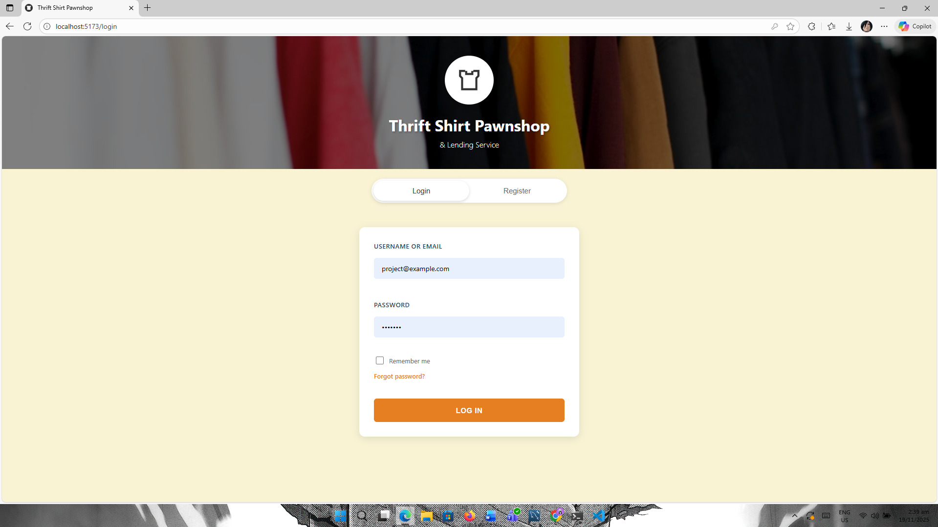  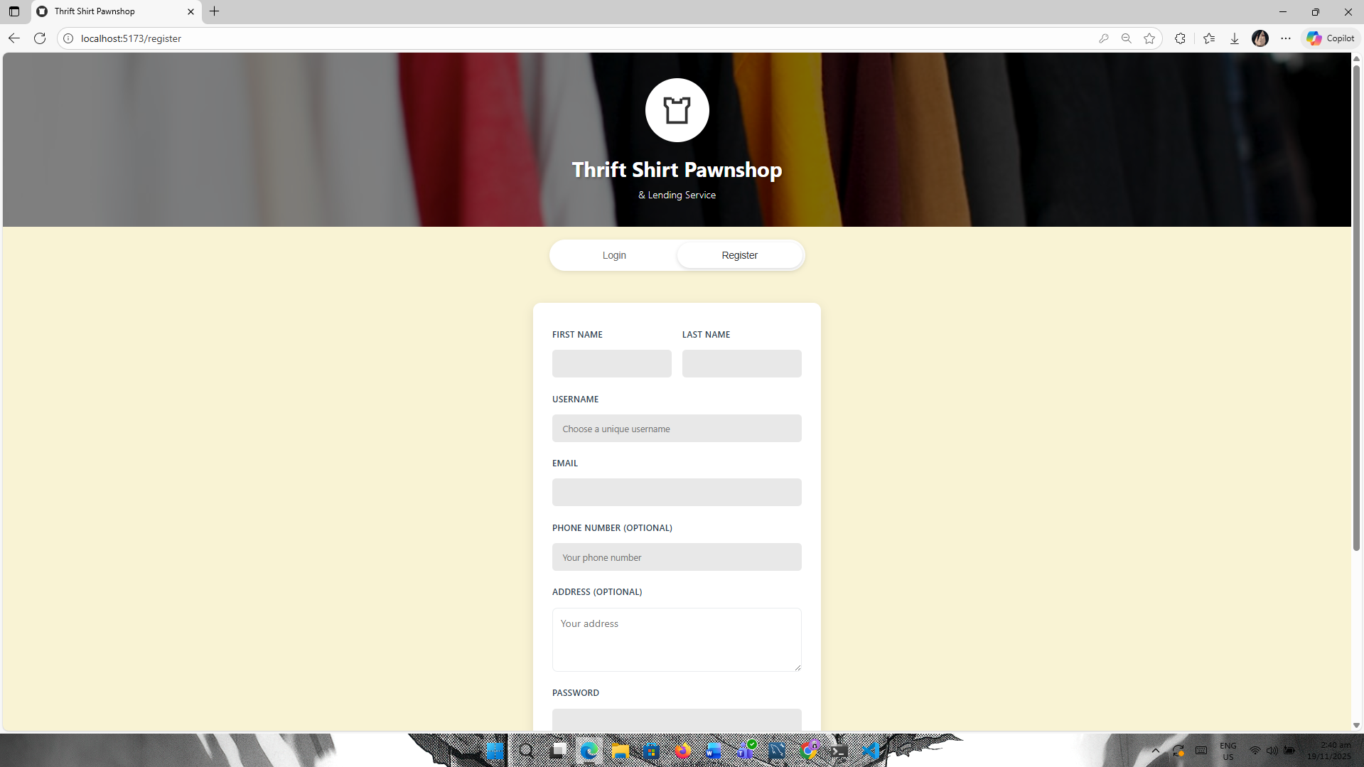  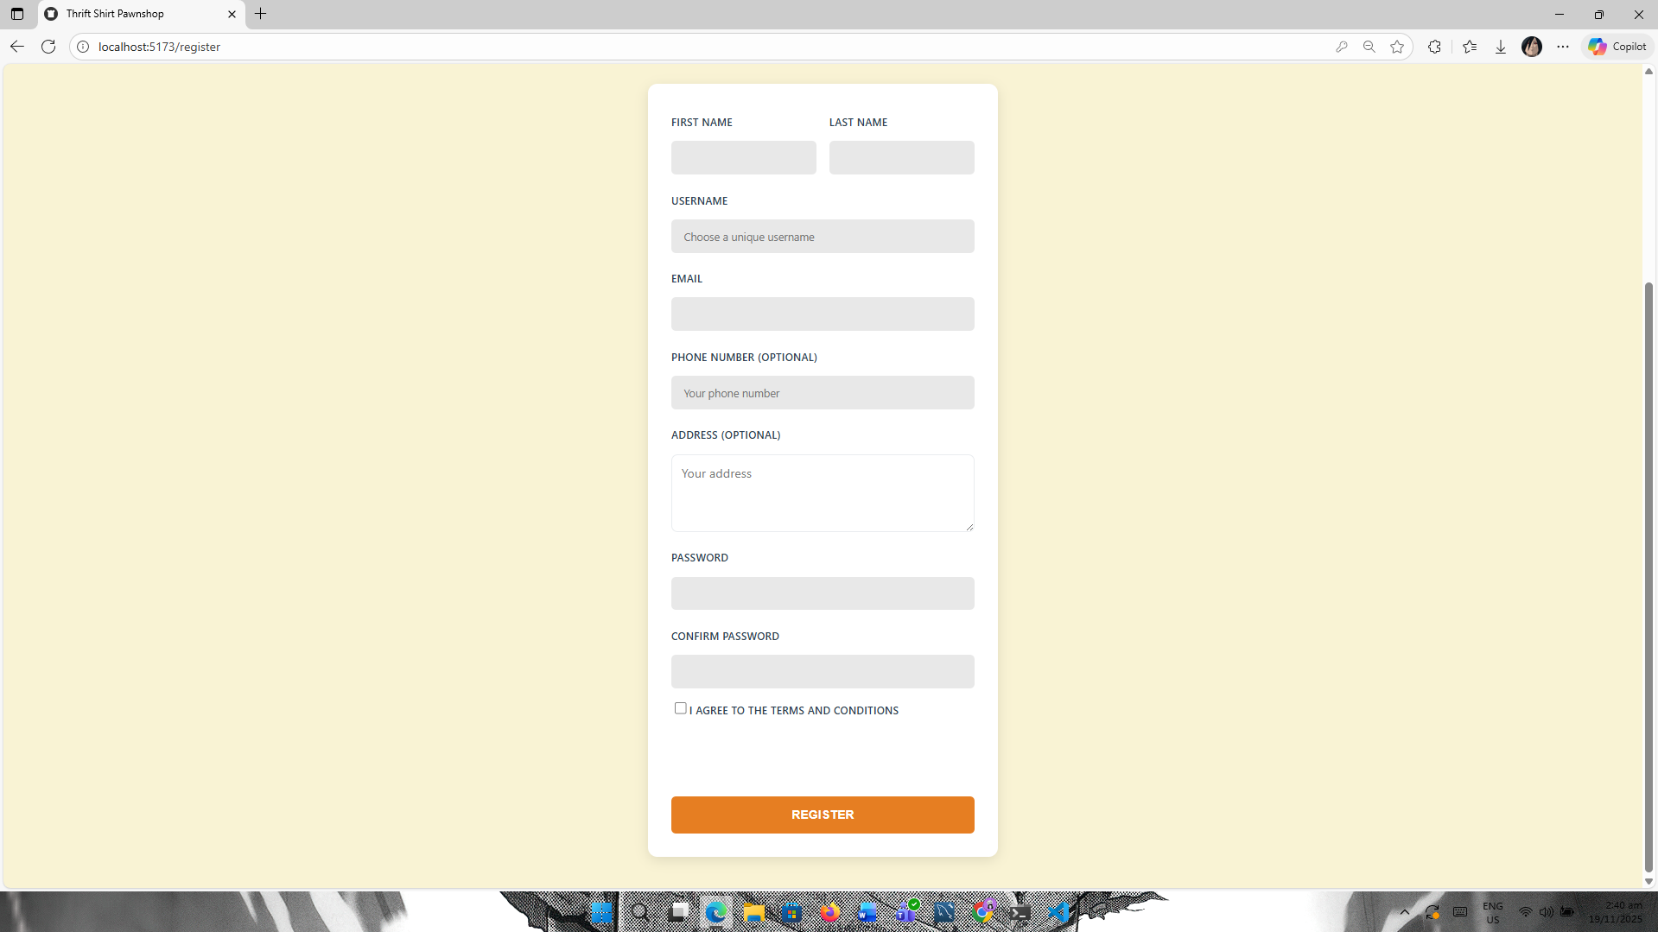  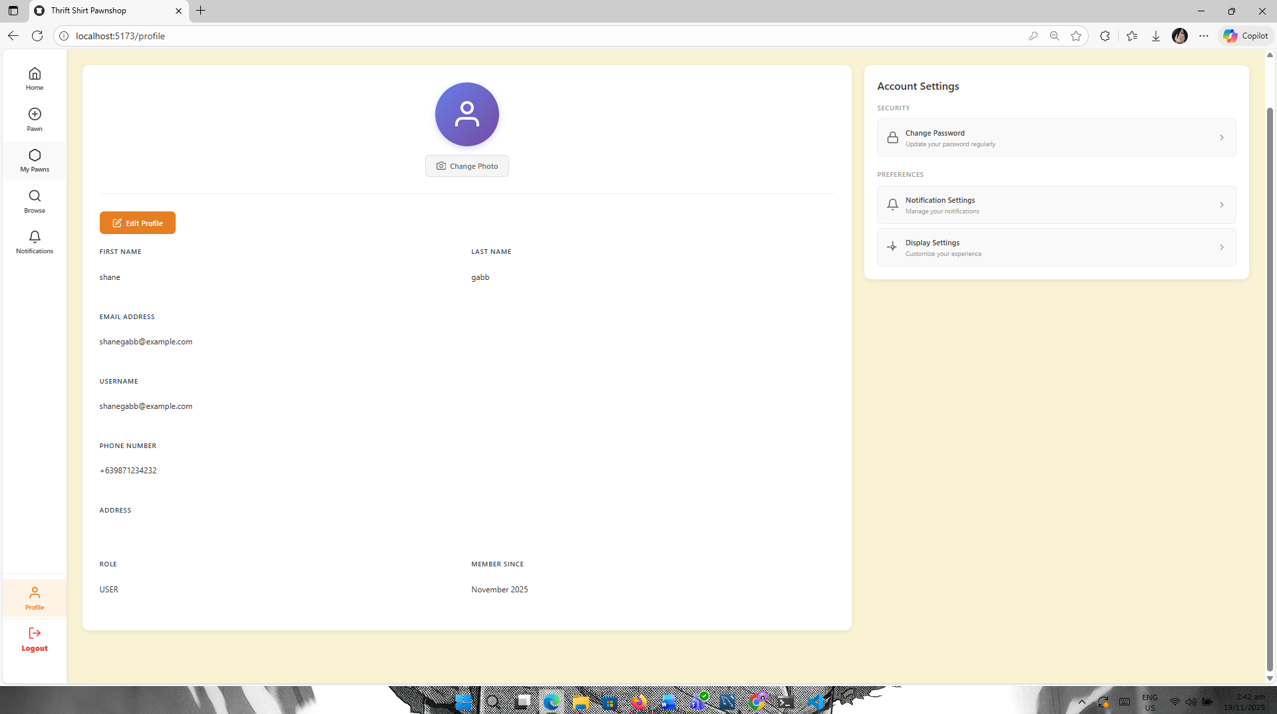
2 | Frontend Ui  -Dashboard  -Browse | 100% | 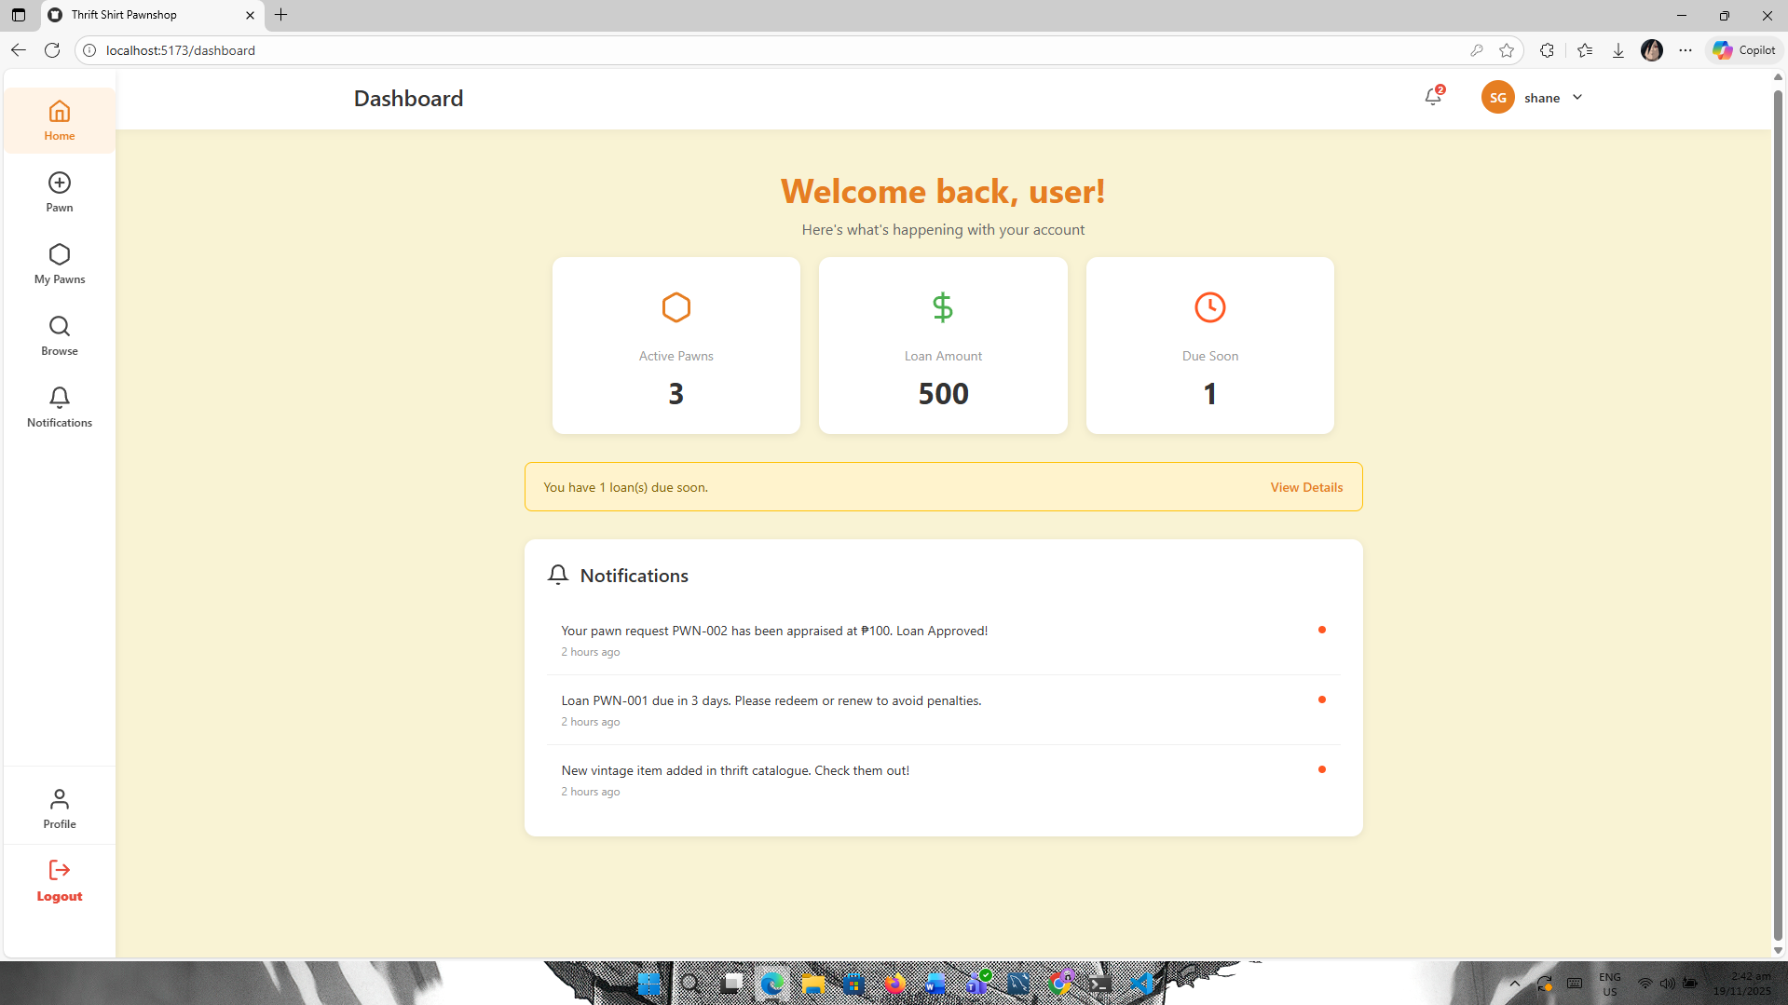  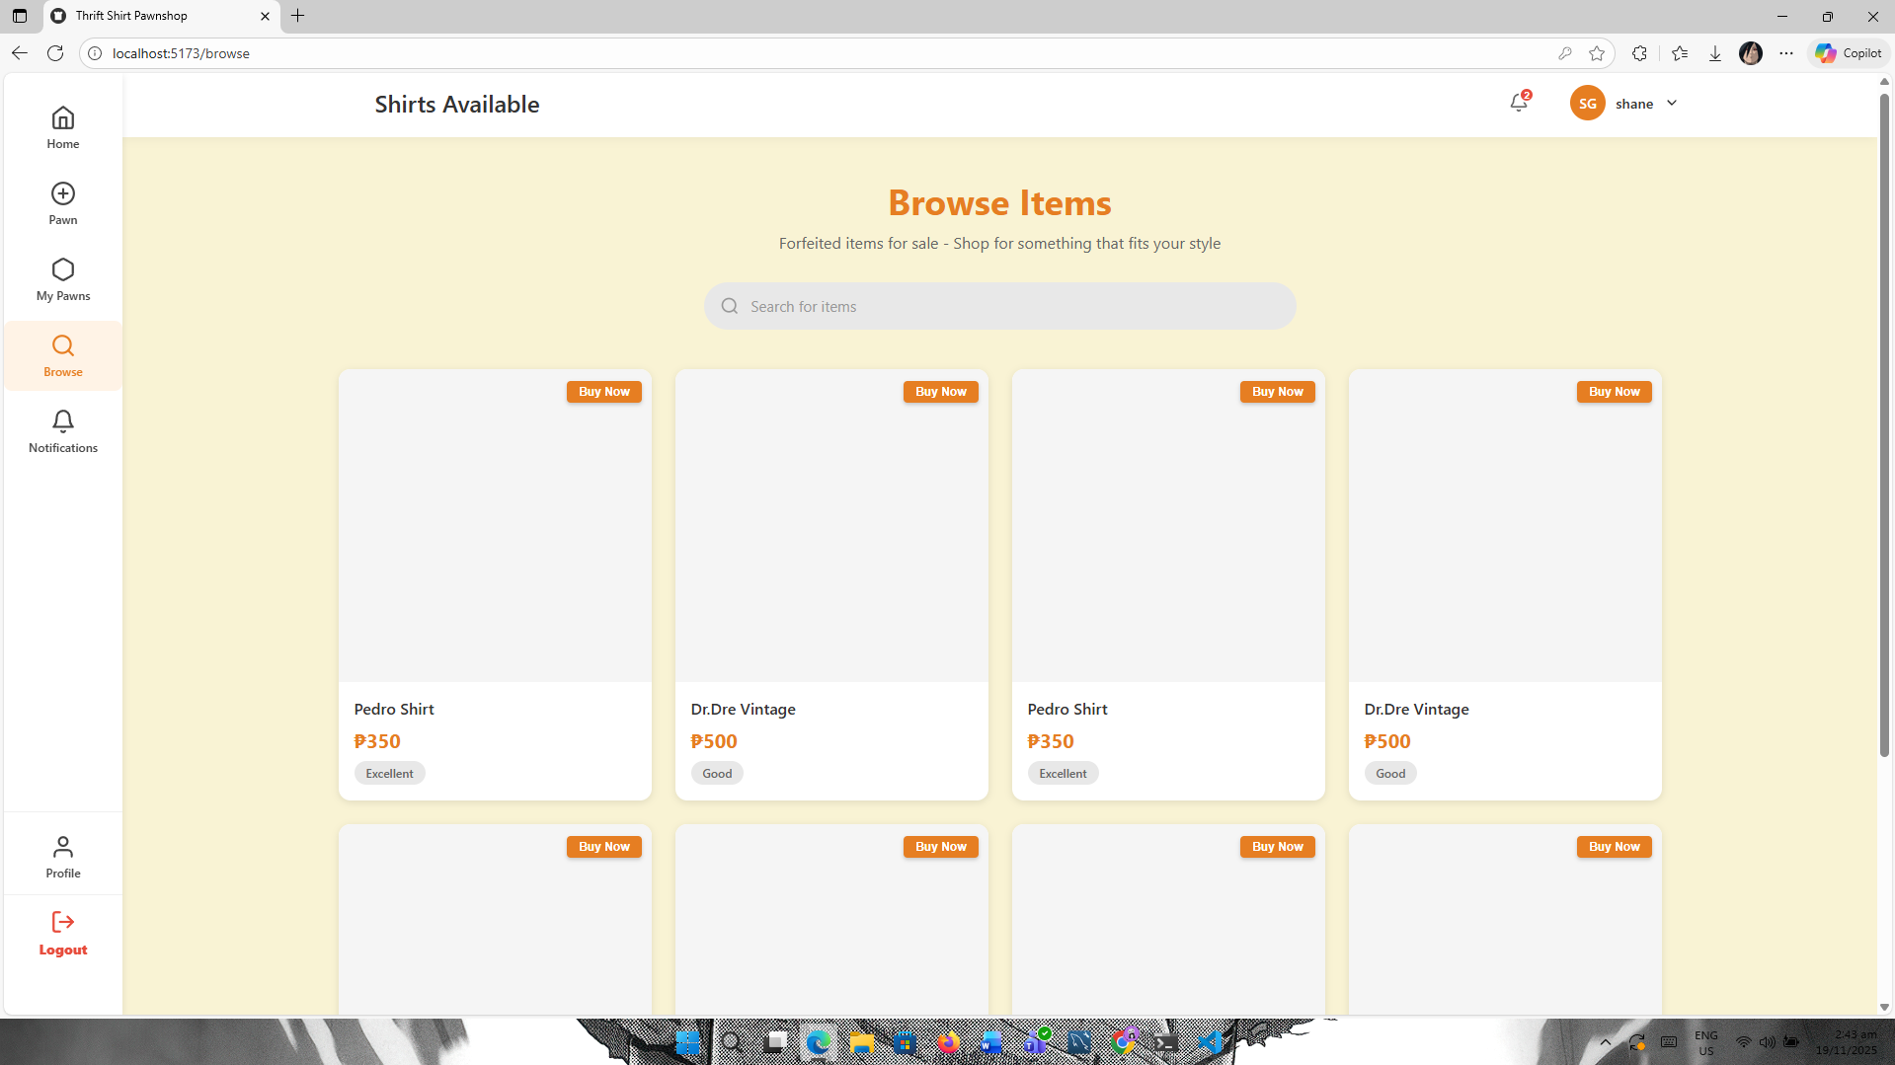

2. Work In-progress
Task ID | Task Name | Progress | Screenshot
3 | Pawn Create / Static | 40% | 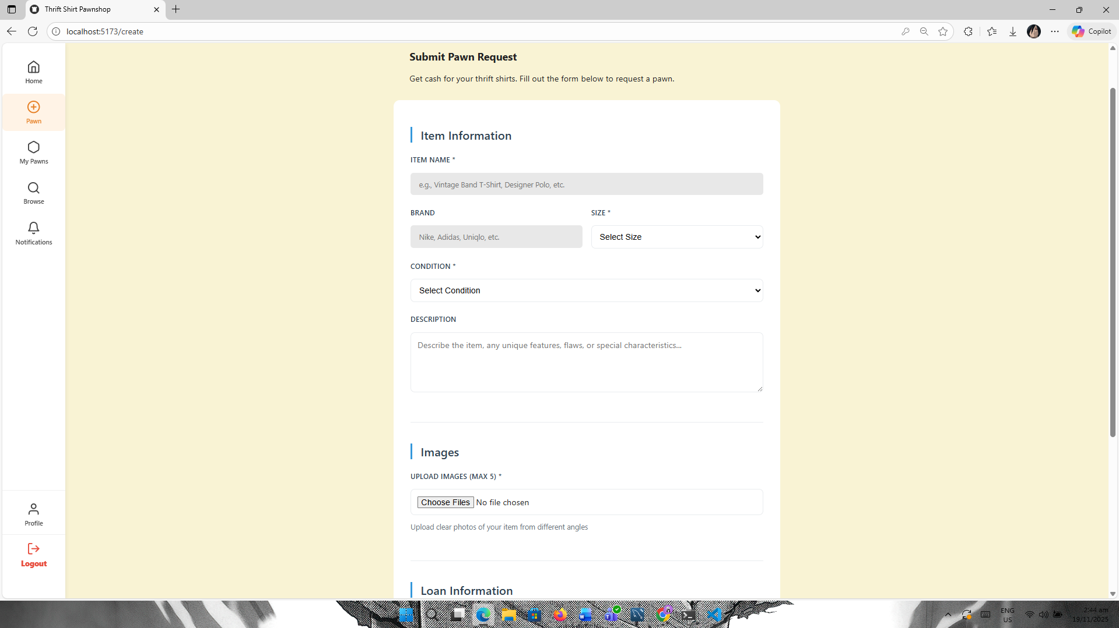  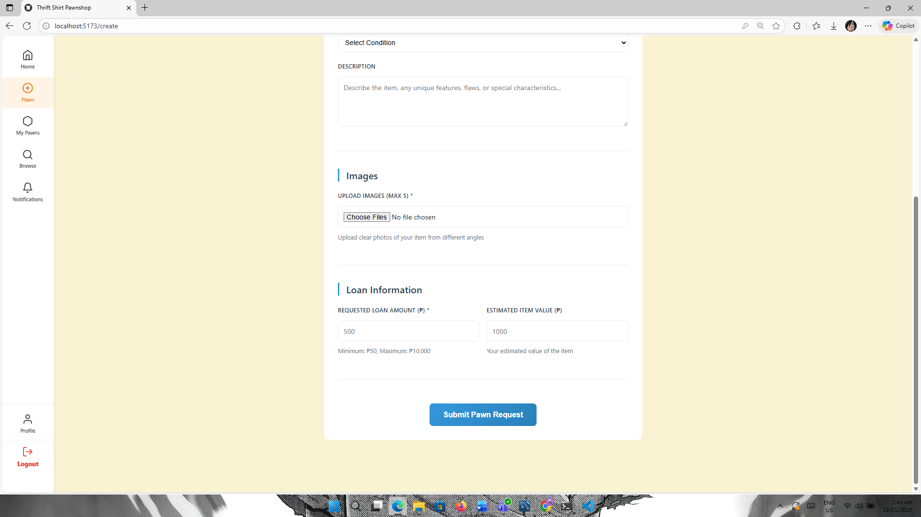
4 | Pawn Status / Static | 40% | 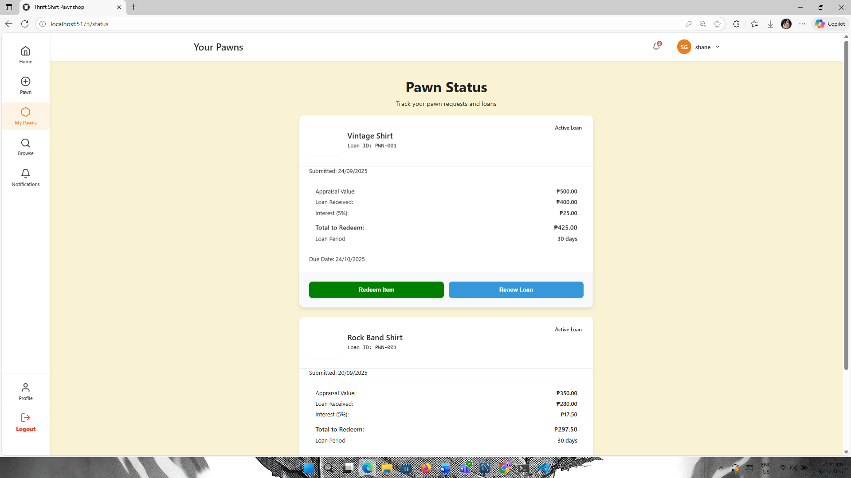  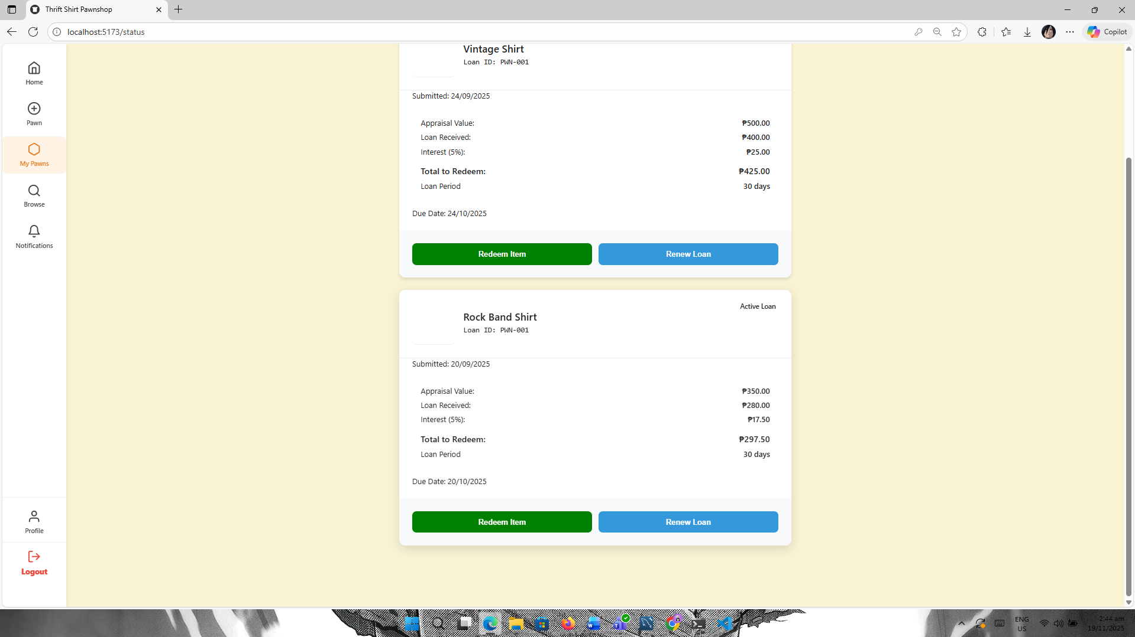

3. Work To-Do
Task ID | Task Name | Progress | Screenshot
3 | ADMIN and Staff UI Frontend Login/ Dashboard/Manage Item Sales and etc | 0%

4. Action Items
- Waiting for the lead developer’s next instructions and task assignments.
- Keeping track of ongoing items and getting ready for upcoming tasks.
- Frontend Developer of the Team

5. Approval Sign-ff
 | Full Name | Signature | Date
Prepared By: | Mark Christian Garing |  | 11/05/2025
Approved By: | Mr. Frederick Revilleza

